NAME: MUHAMMED ALI QURESHI

ROLL NO: 20k-0149

SECTION: D

1. **What is an algorithm?**

Algorithms are well defined, computer-implementable instruction, typically to solve a class of problems or to perform a computation. Algorithms are used for performing calculations, data processing, automated reasoning, and other tasks. n algorithm can be expressed within a finite amount of space and time.

**Explain need of an algorithm?**

Algorithms are often quite different from one another. It is entirely possible that there are many different ways to implement the details to compute the one function. One algorithm may use many fewer resources than another. One algorithm might take 10 times as long to return the result as the other. We would like to have some way to compare these two solutions. Even though they both work, one is perhaps “better” than the other. One is more efficient or that one simply works faster or uses less memory. Algorithms have techniques that allow us to compare and contrast solutions based solely on their own characteristics, not the characteristics of the program or computer used to implement them.

**4) Explain steps involve in drawing of a flowchart.**

TERMINATOR

Indicate the beginning or end of

The program drawn in the program

**PROCESS**

It indicates any processing

Function.

**DECISION**

Indicate a decision point between two

Or more paths in a flowchart.

**CONNECTOR**

It represent the input and output of the

Flowchart

**Explain uses of Flowchart.**

A flow chart allows you to layout a complex set of interactions in a way that is easier to digest. For example a process flowchart typically includes a series of activities, inputs, outputs and roles (the people that do the activities) in a sequence. The sequence often has branching where one activity might trigger parallel activities. These sorts of relationships are very hard to visualize when written as text. So a flowchart helps to turn that into a picture that makes it easier for people to understand, discuss and communicate. Flowchart can be used for planning a new project, Documenting a process, Modeling a business process, Managing workflow, Auditing a process, Mapping computing algorithm and Data management.QUESTION 06)

STEP1) Start

STEP 2) Go to the market

STEP 3) Input RS 500

STEP 4) Purchase 2 kilogram of apple for 100 RS

STEP 5) Purchase 1.5 kilogram of mangoes for 52.5 RS

STEP 6) Purchase 2.5 kilogram of potatoes for 25 RS

STEP 7) Purchase 1 kilogram of tomatoes for 15 RS

STEP 8) Pay RS 500 to the shopkeeper

STEP 9) Take back the change of shopkeeper amounting to 307.5 RS

STEP 10) Item purchased are potatoes, mangoes, apple and tomatoes.

STEP 11) END

QUESTION 05)

1. Find factorial of N?

PROBLEM ANALYSIS CHART

|  |  |  |
| --- | --- | --- |
| DATA | PROCESS | OUTPUT |
| Input N | Counter=0  T=1  Count=count+1  F=C*T | N-Factorial |

**HIPO**

Factorial of N

0000

Counter=0

T=1

Count=count+1

F=C*T

2000

N-Factorial

3000

Input N

1000

IPO

|  |  |  |  |
| --- | --- | --- | --- |
| DATA | PROCESS | MODULUS | OUTPUT |
| Input N |  | 1000 |  |
|  | Counter=0  T=1  Count=count+1  F=C*T | 2000 |  |
|  |  | 3000 | N-Factorial |

START

INPUT N

C=0

T=1

C=C+1

F = C*T

C=N

NO

END

PRINT F

YES

PSEUDO CODE:

STEP 1) START

STEP 2) Input N

STEP 3) C←0

T←1

STEP 4) C←C+1

STEP 5) F←C*T

STEP 6) C==N

If not repeat the process from step 4

Step 7) Else print (F)

Step 8) END

**B) Find the sum of first 100 natural numbers.**

PROBLEM ANALYSIS CHART

|  |  |  |
| --- | --- | --- |
| DATA | PROCESS | OUTPUT |
| Input number N | S=0  C=0  C=C+1  S=S+C | Sum |

IPO

|  |  |  |  |
| --- | --- | --- | --- |
| INPUT | PROCESS | MODULUS | OUTPUT |
| INPUT N |  | 1000 |  |
|  | S=0, C=0  C=C+1  S=S+C | 2000 |  |
|  |  | 3000 | PRINT SUM |

START

0000

PRINT SUM

3000

S=0, C=0

C=C+1

S=S+C

2000

INPUT N

1000

**PSUDO CODE:**

STEP 1) Start

Step 2) s←0

C←0

Step 3) Input ←N

Step 4) C←C+1

Step 5) s ← s + c

Step 6) c>100

If no ←repeat from step 4

Step 7) else← print (sum)

Step8) End

PRINT SUM

INPUT = N

S=0

C=0

STOP

C>100

S=S+C

C=C+1

START

NO

YES

**C) Find the largest of three numbers x, y and z.**

**PAC**

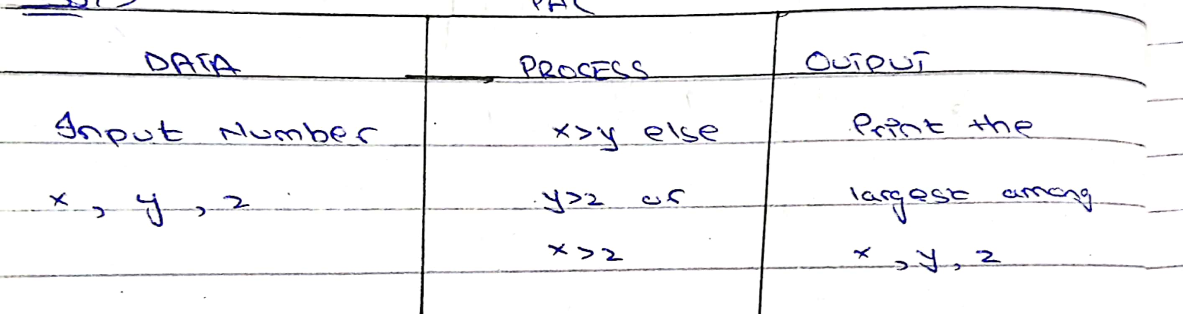

**HIPO**

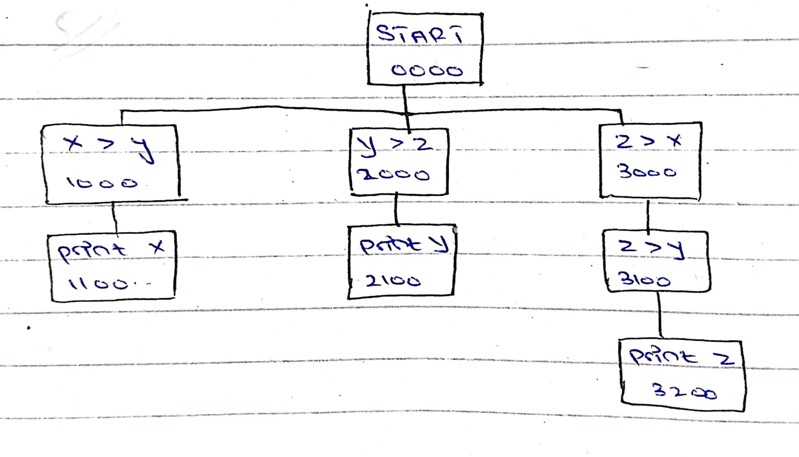

**IPO**

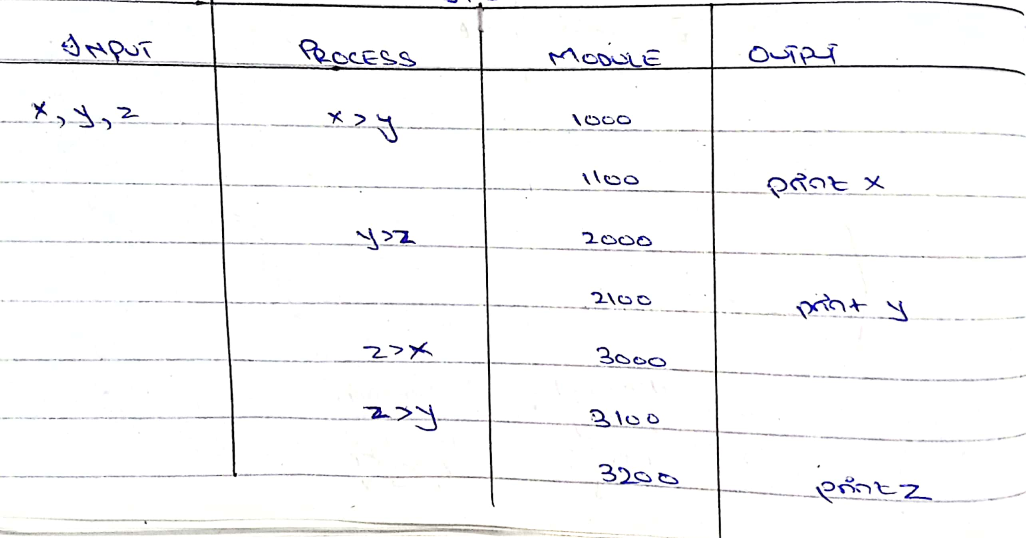

**FLOWCHART**

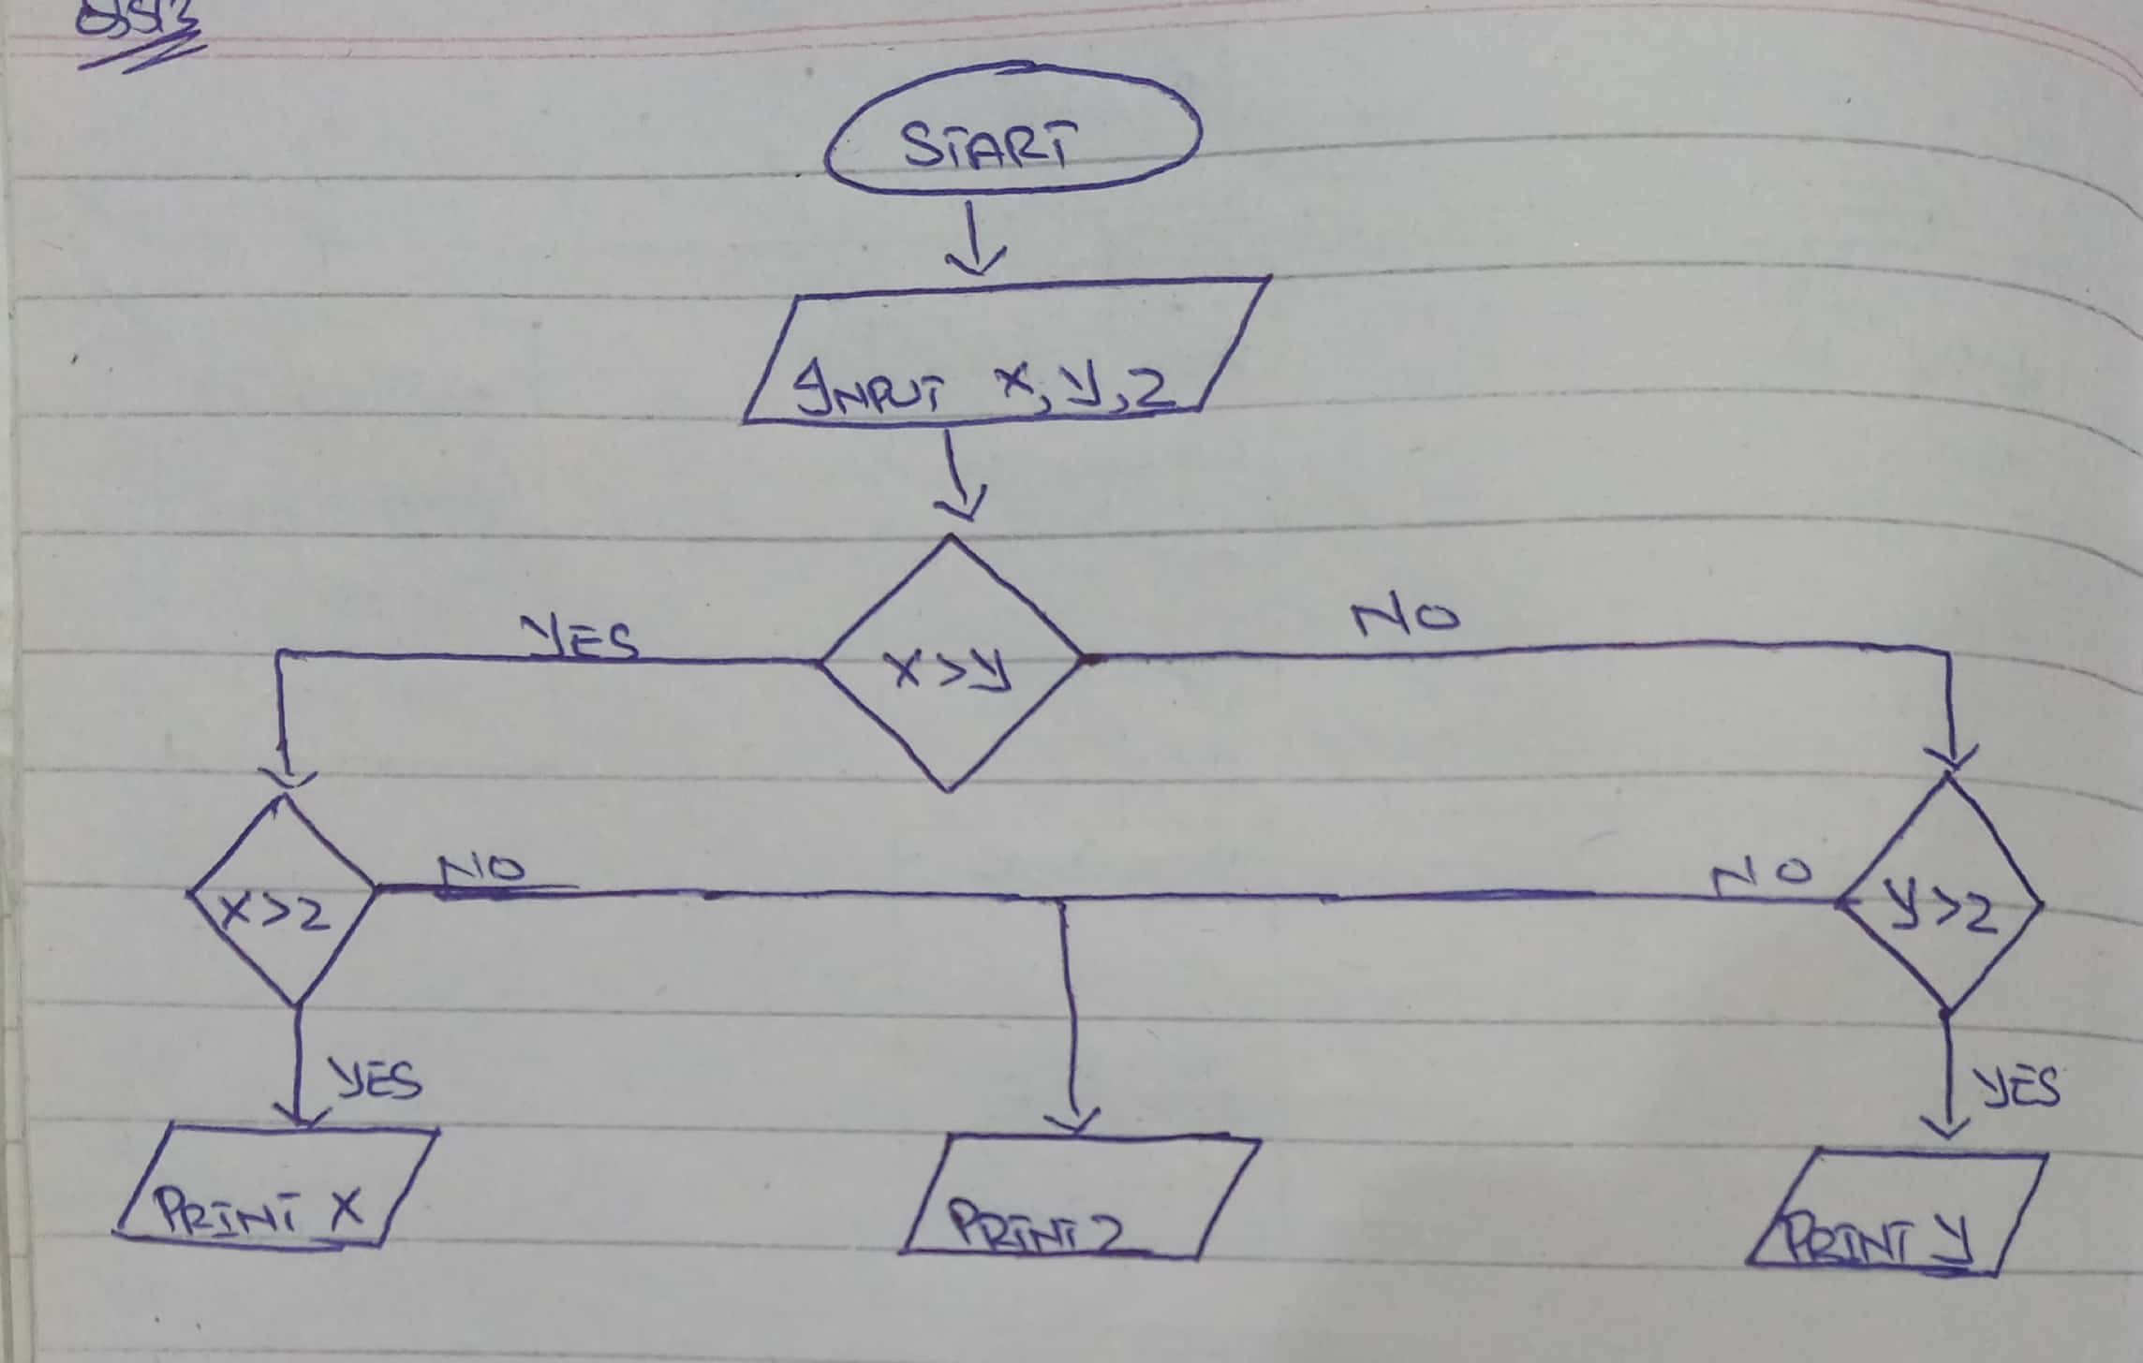

**PSEUDO CODE**

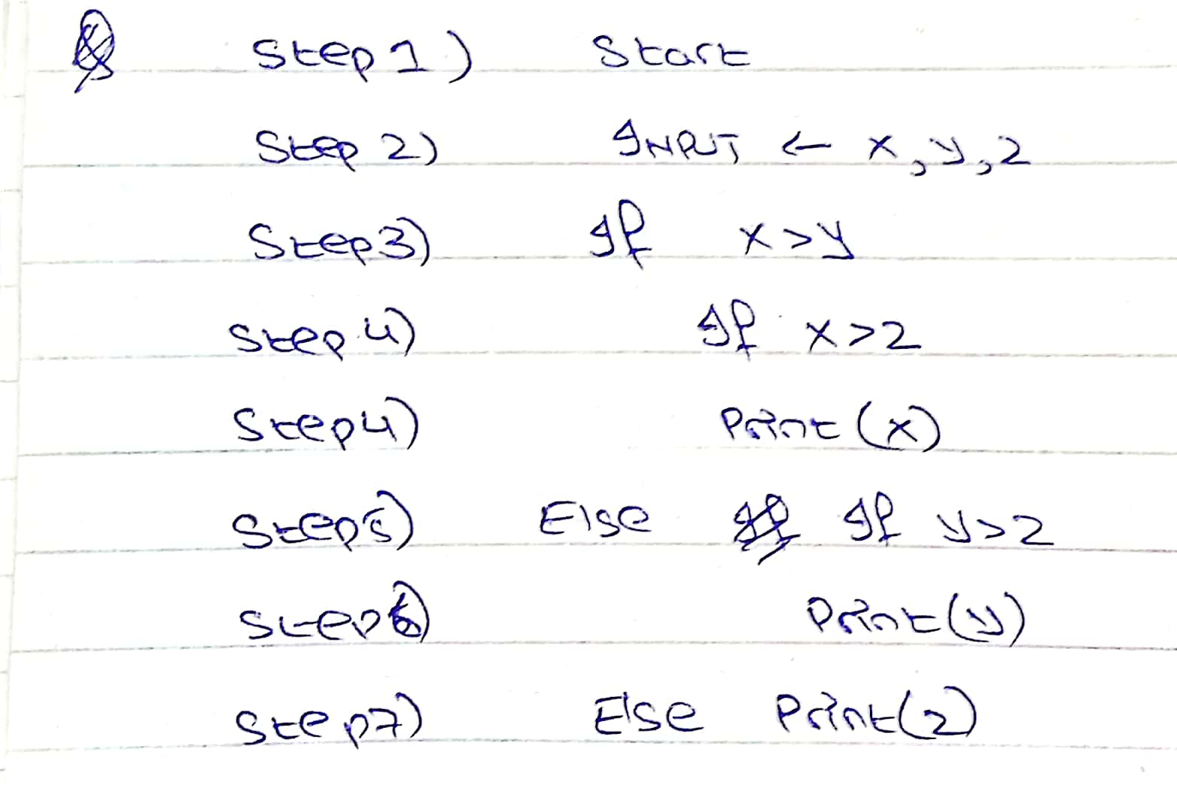

**D) Determining prime number?**

**PAC**

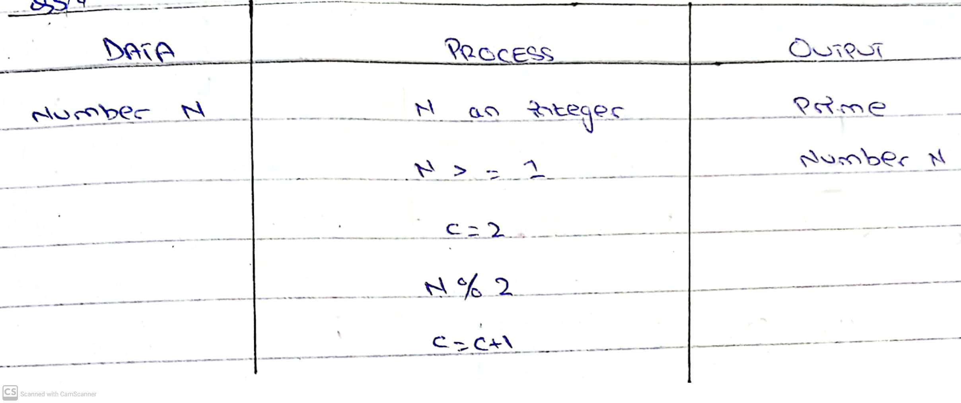

**HIPO**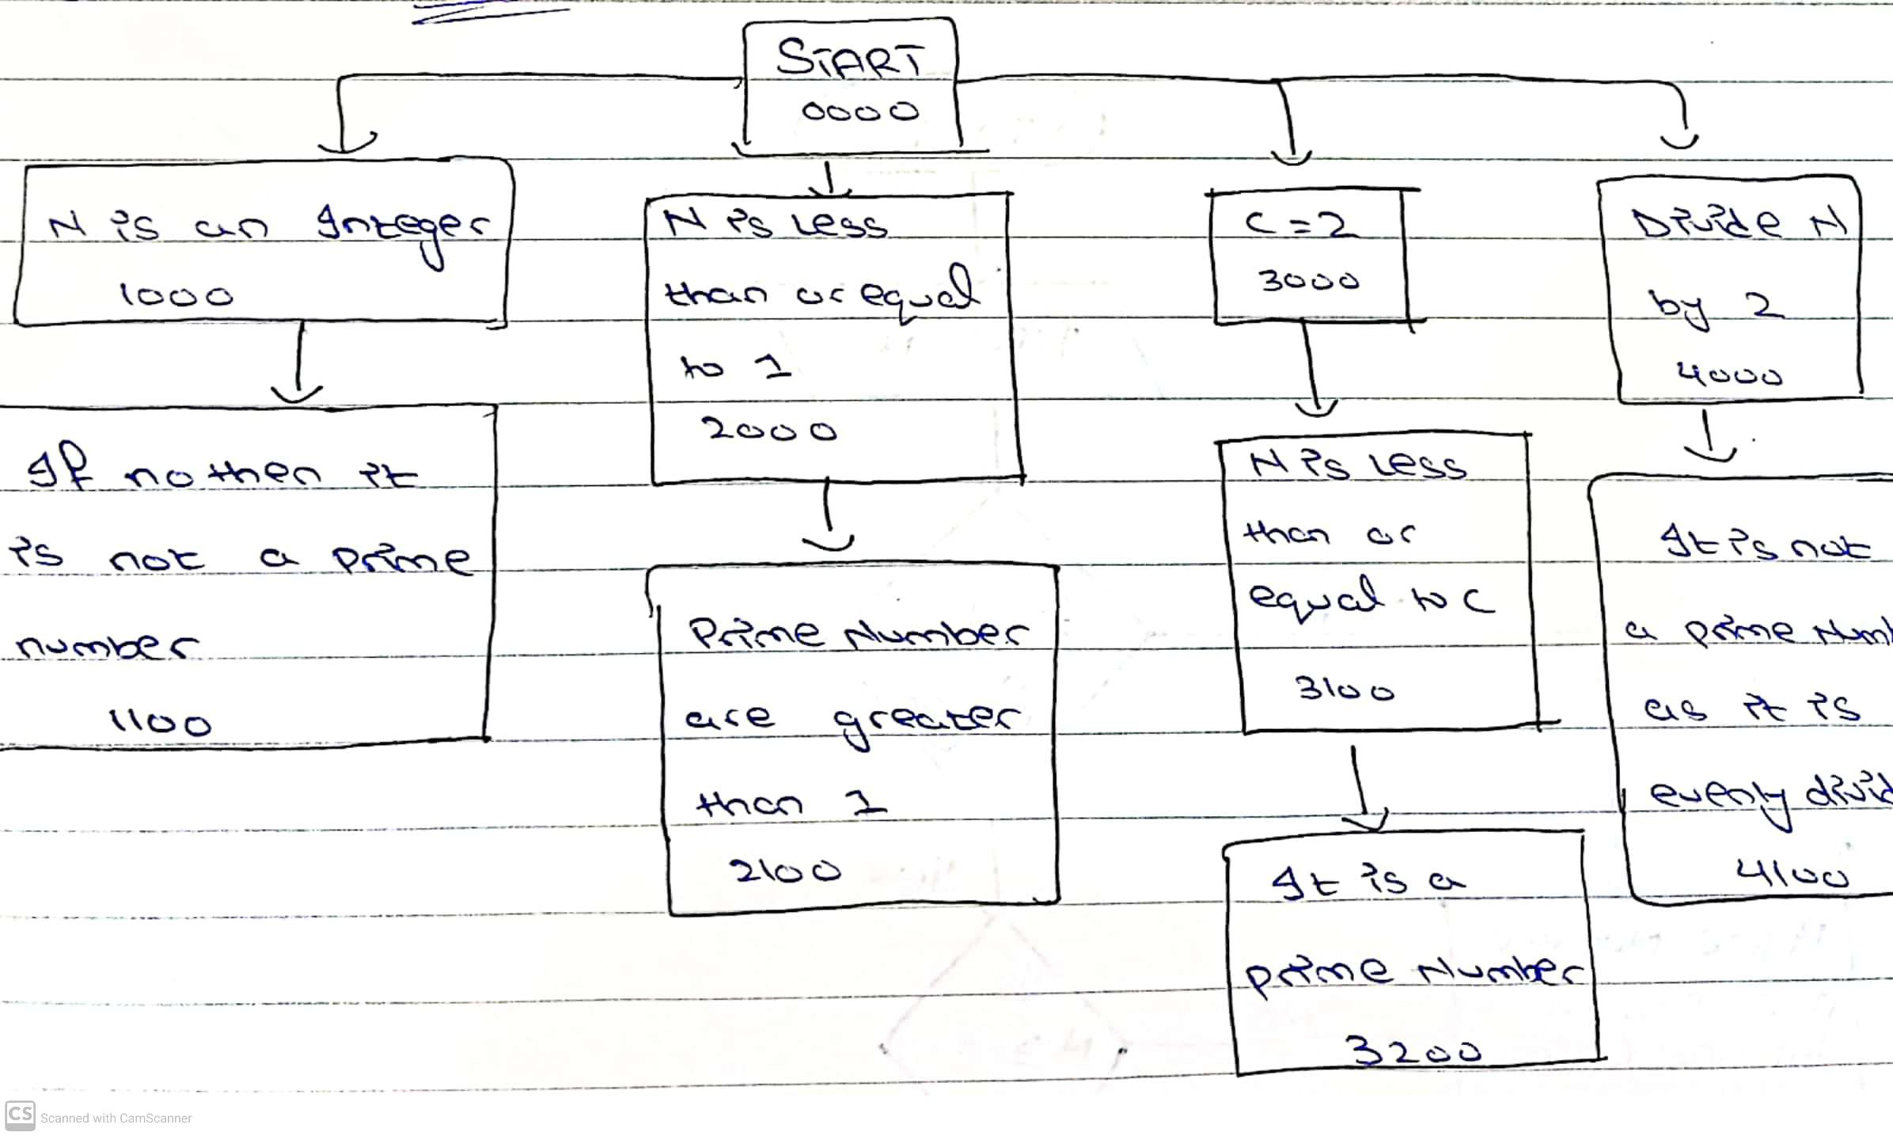

**IPO**

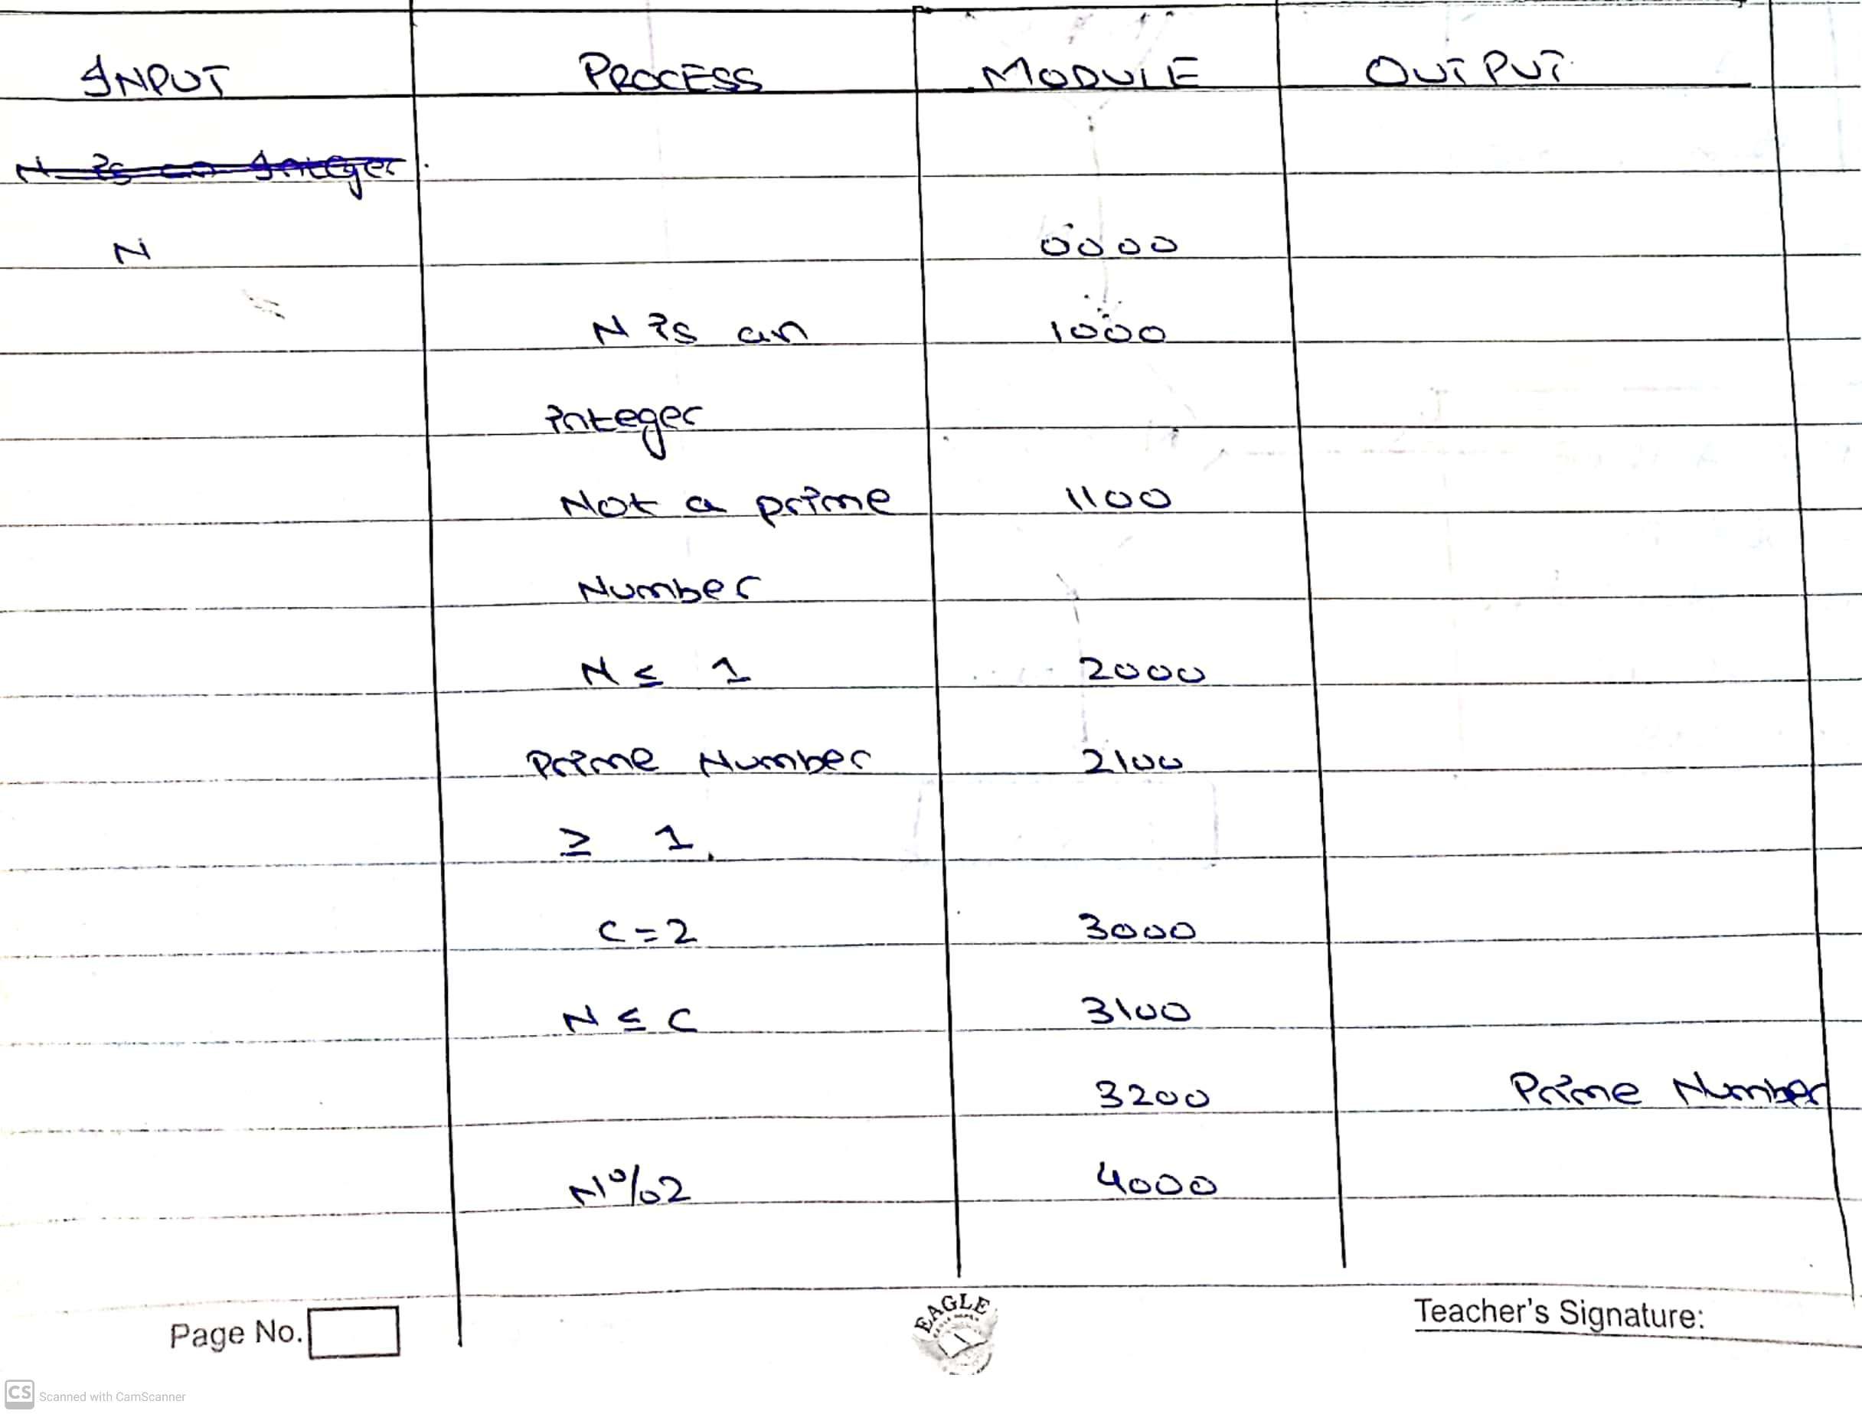

**FLOWCHART**

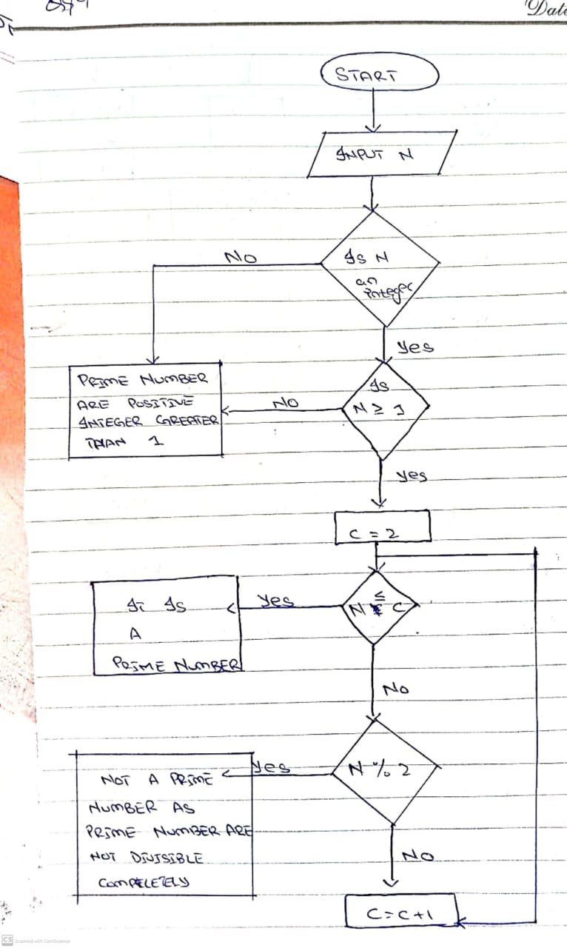

**PSEUDO CODE**

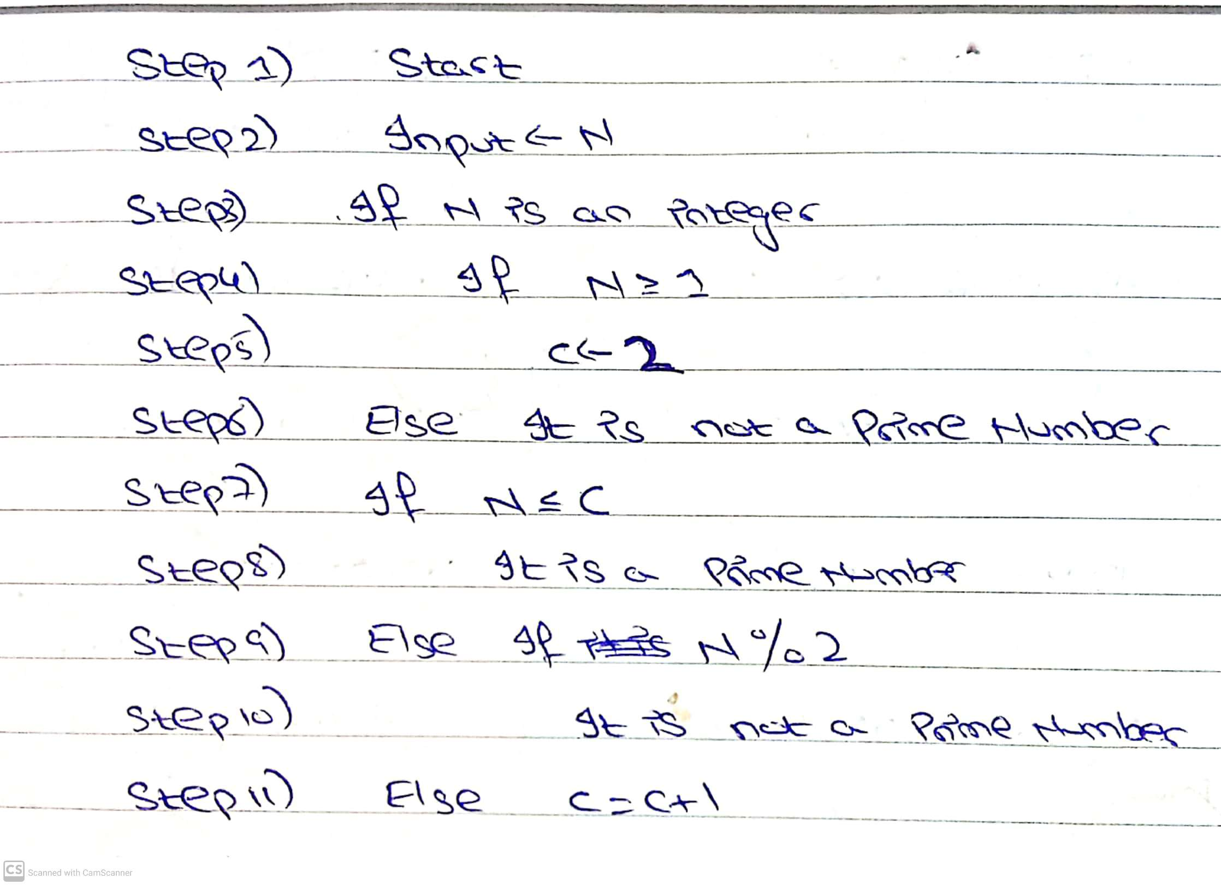

**E) A program which generates first 50 items of the Fibonacci series: 1, 1, 2, 3, 5, 8,**

**PAC**

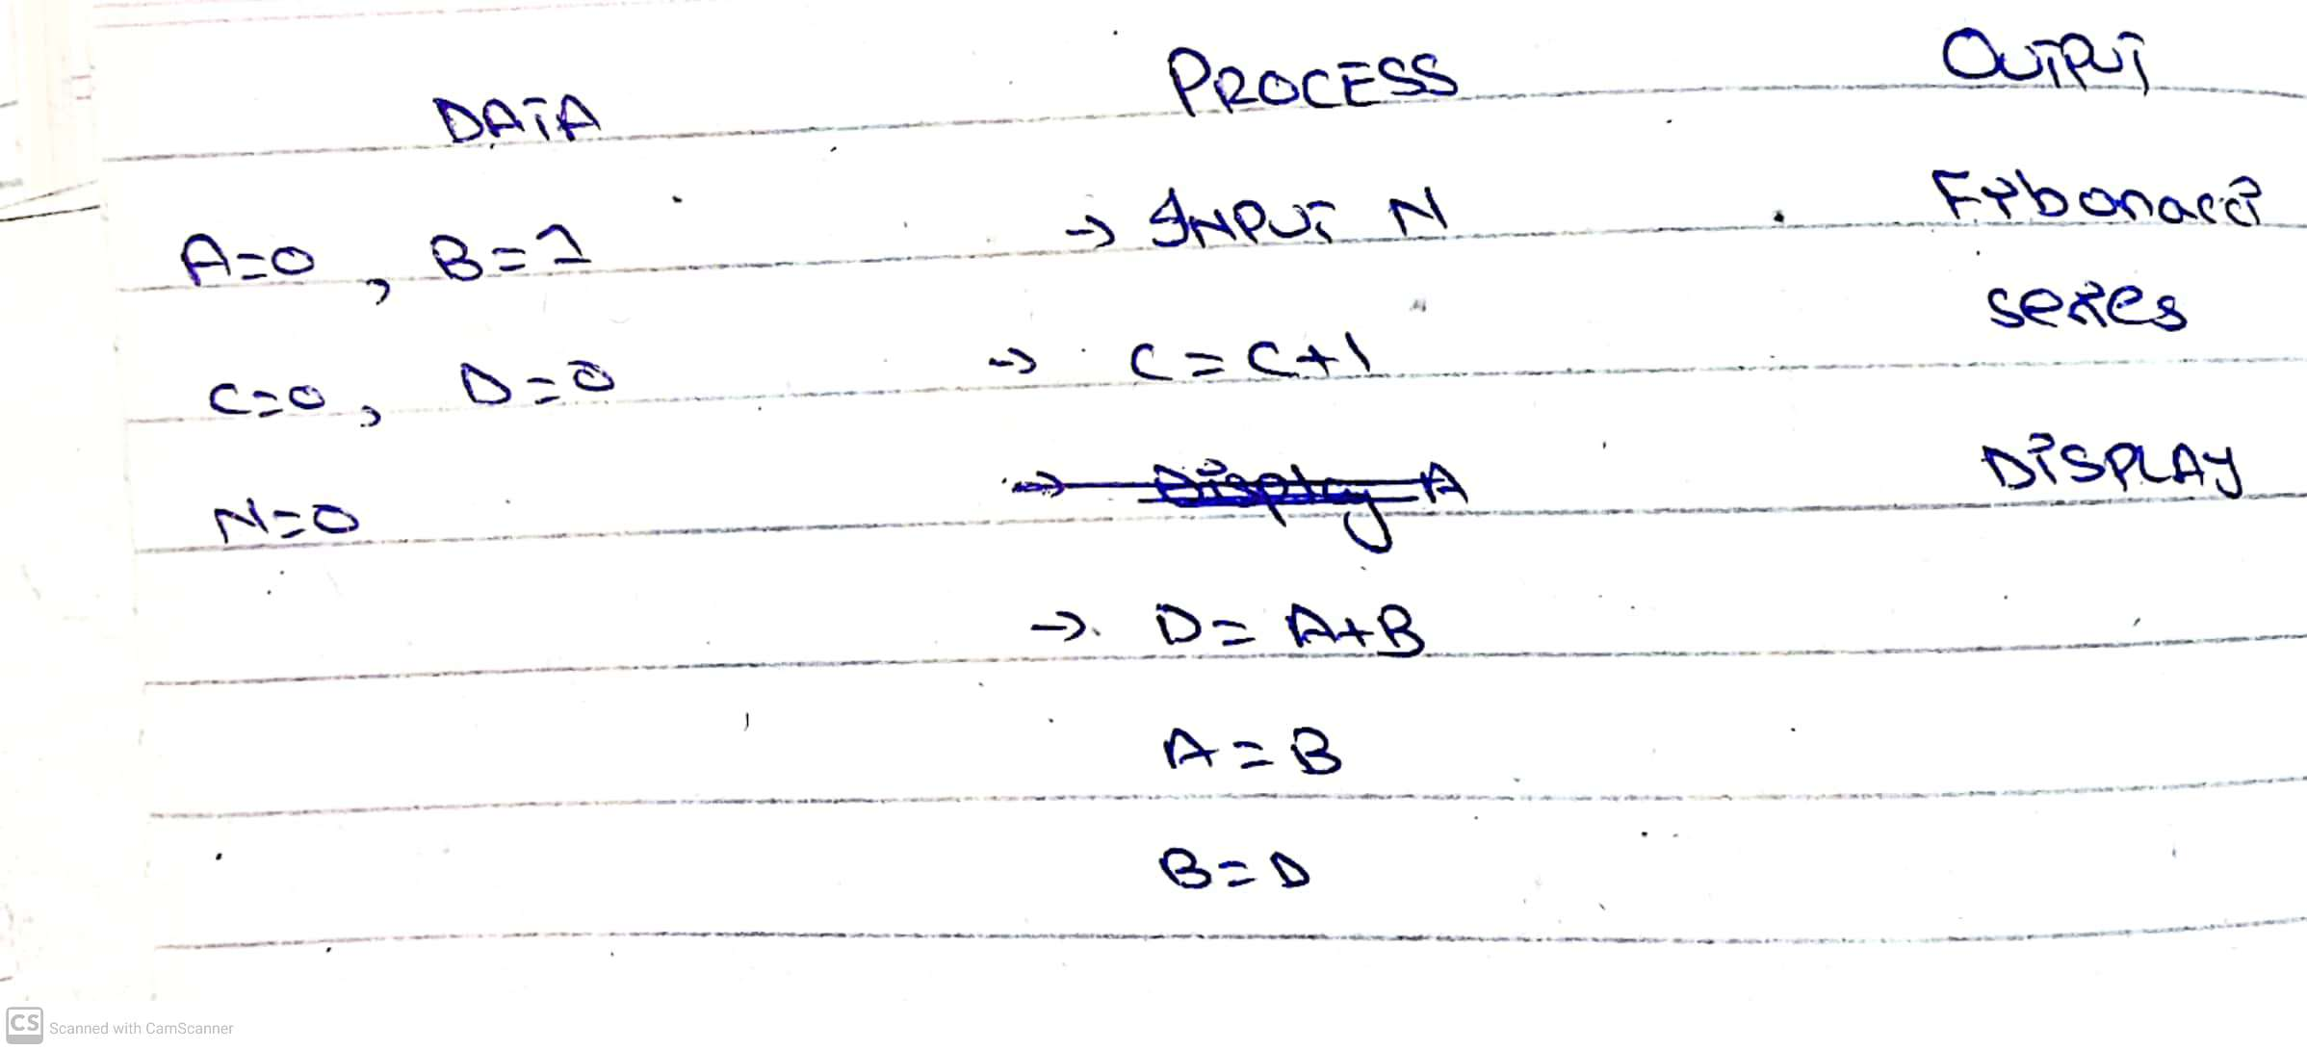

**HIPO**

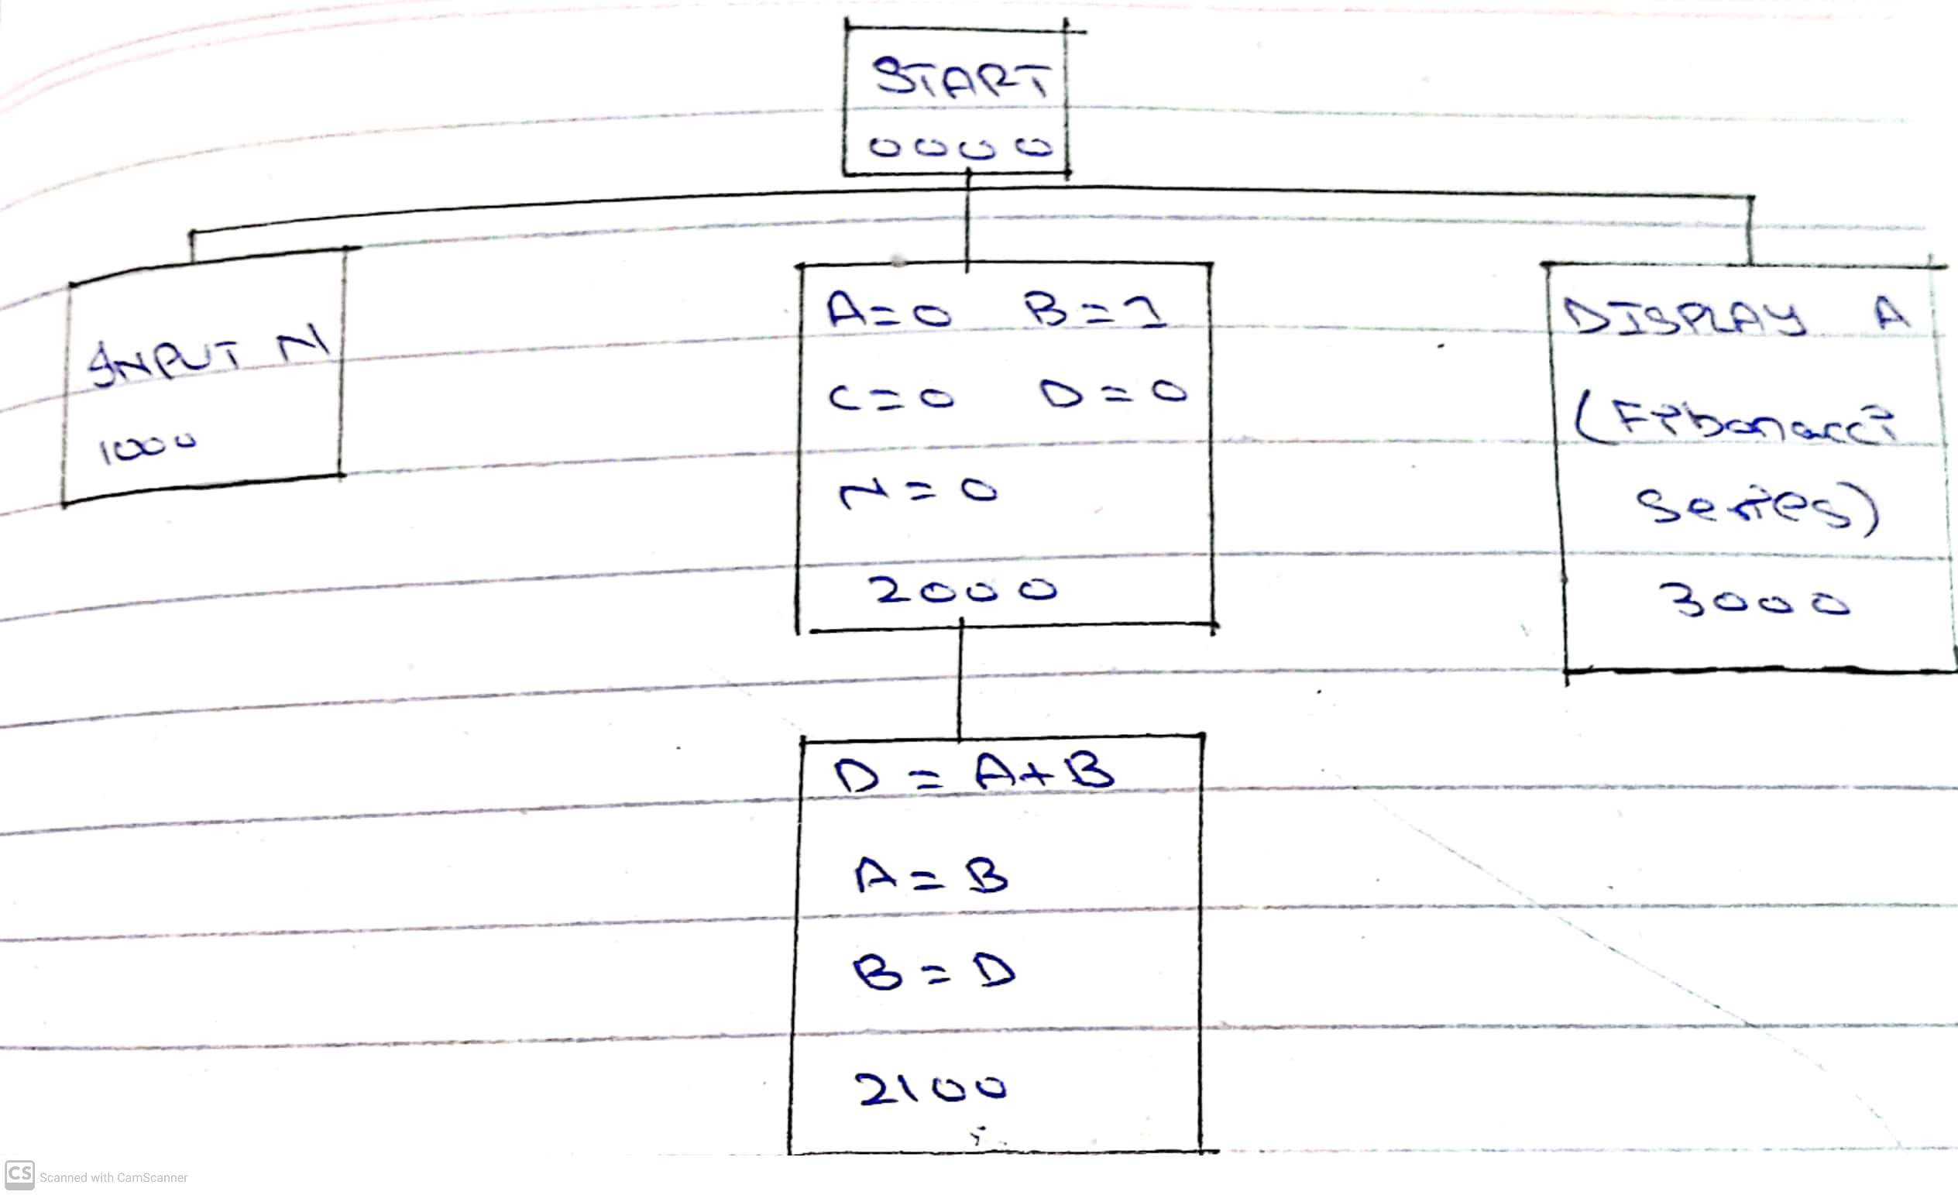

**IPO**

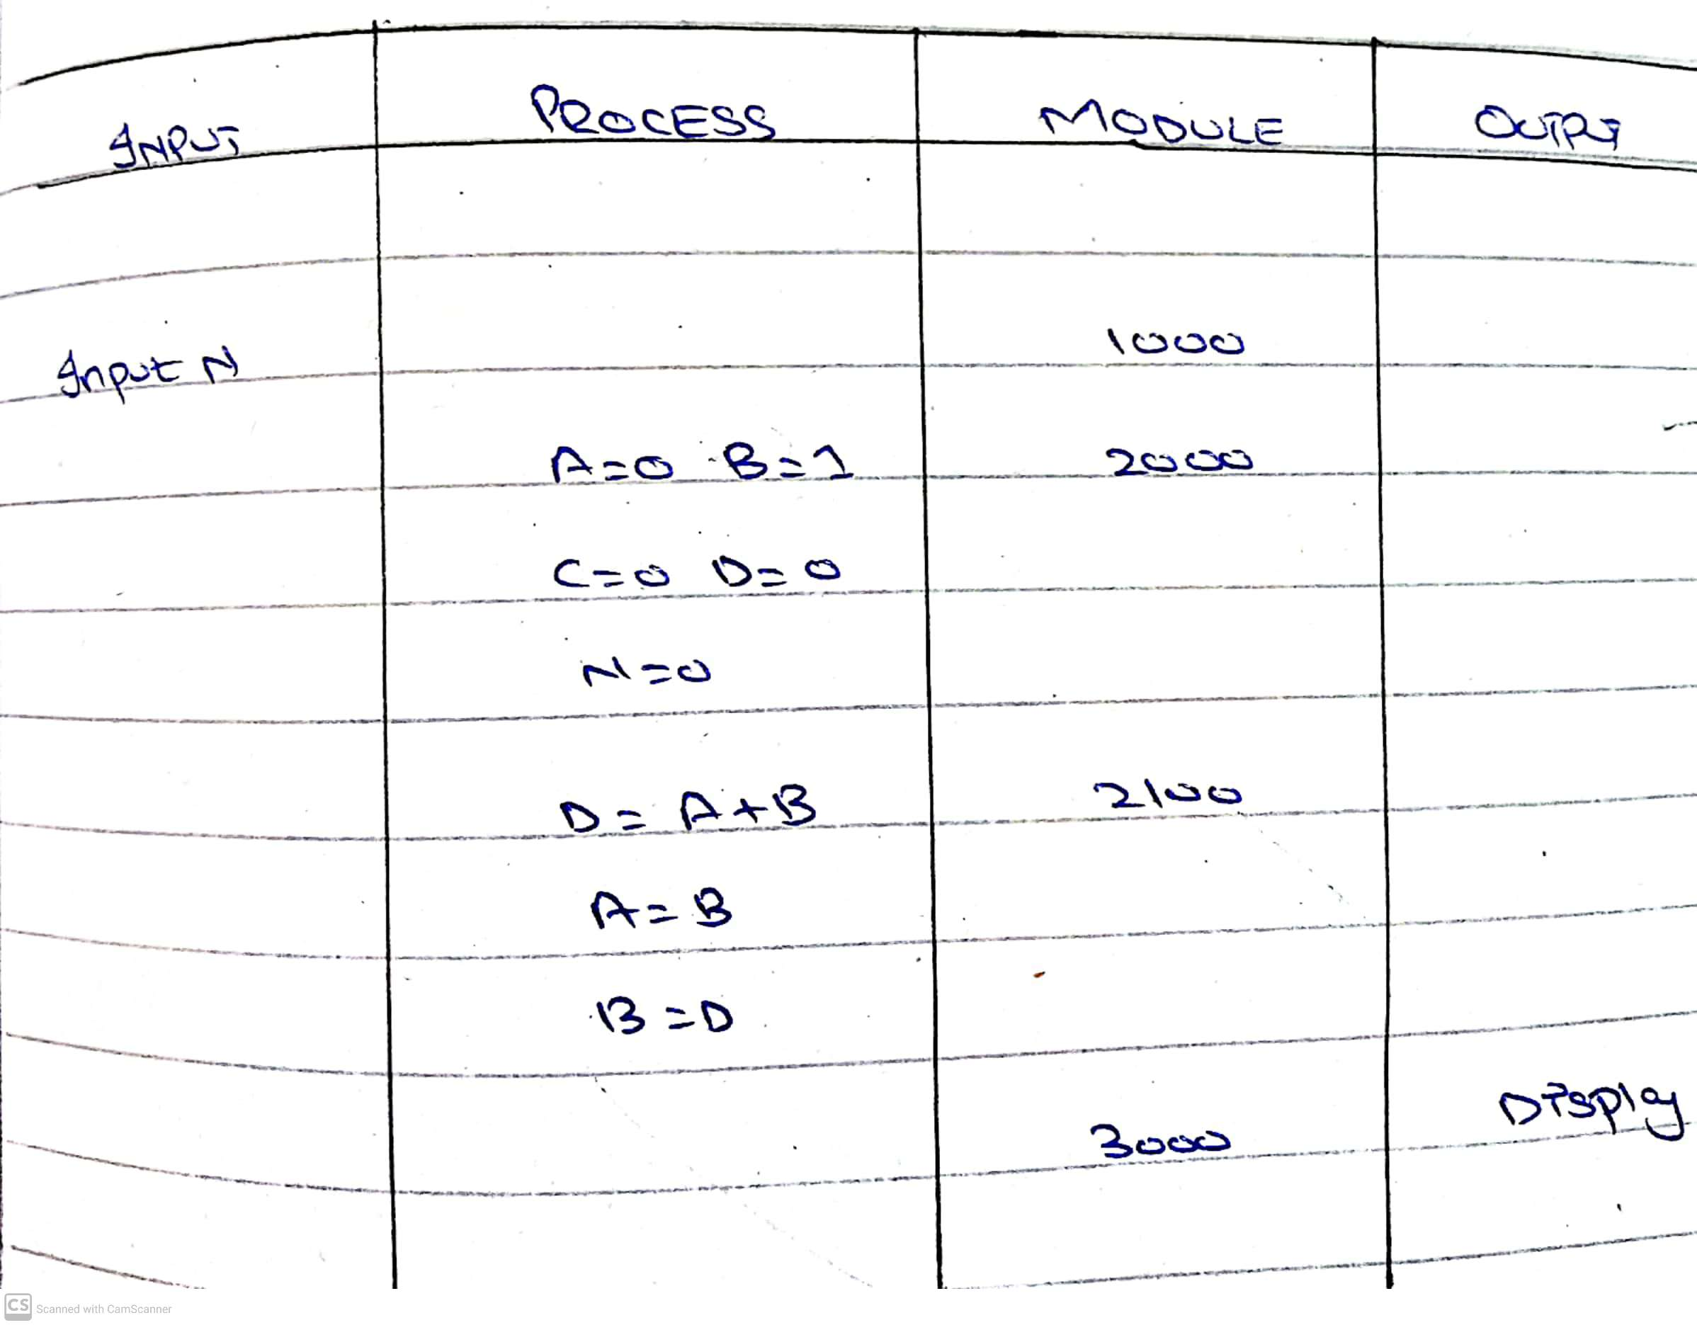

**FLOWCHART**

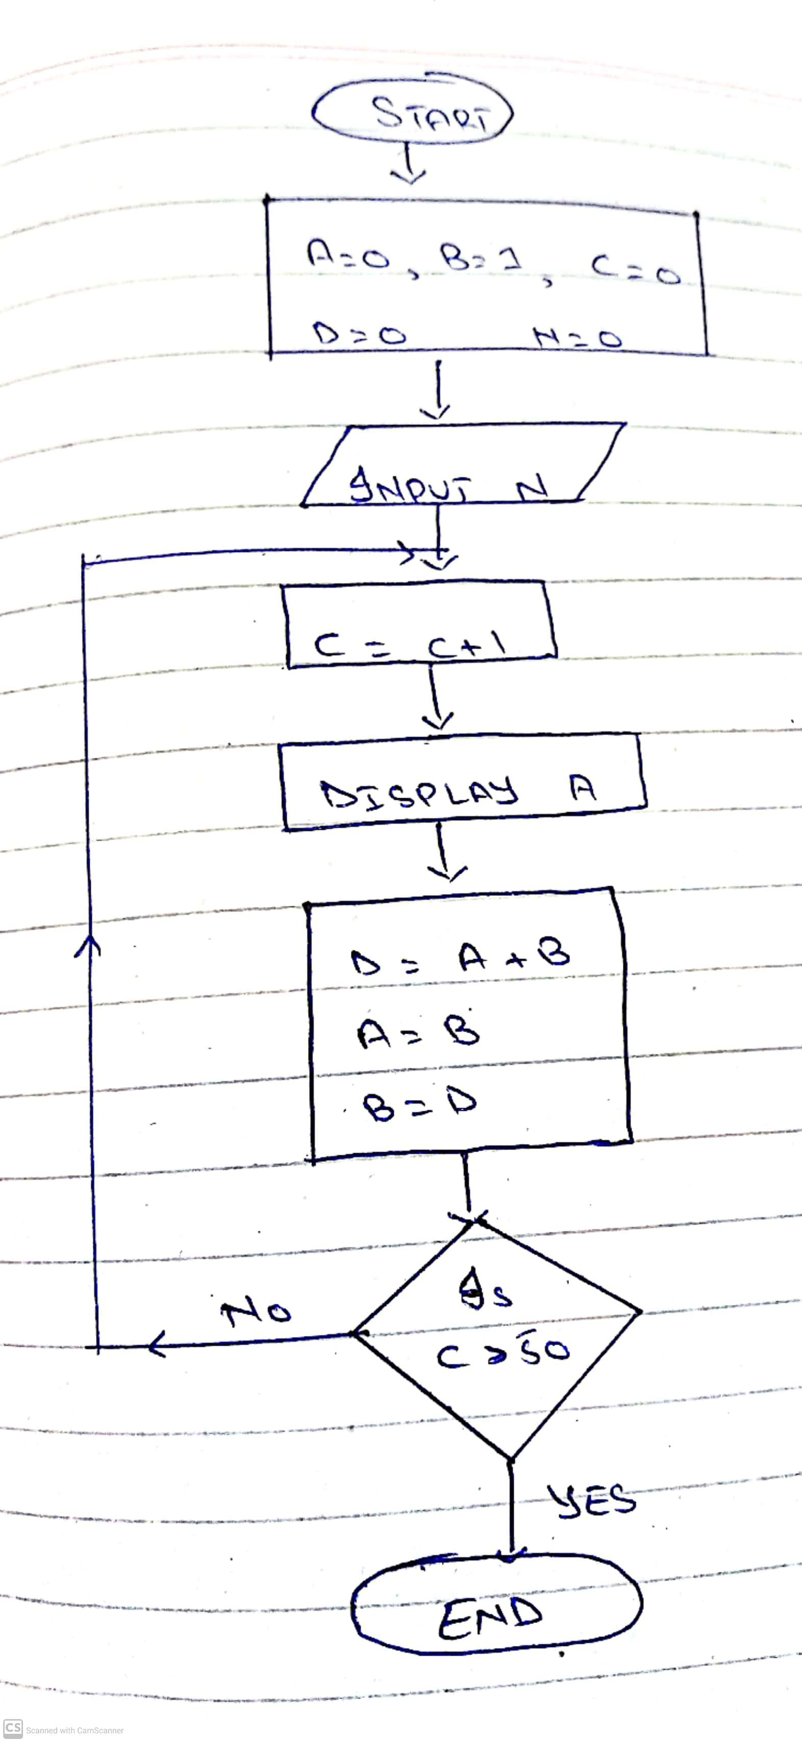

**PSEUDO CODE**

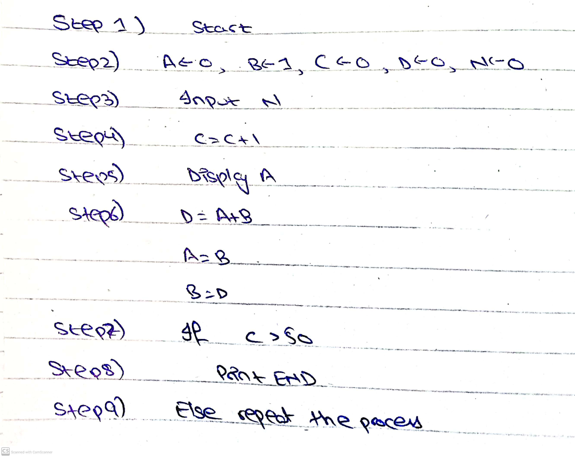

**6. Draw Flowchart of 5 problems of your own choice. But people should come up with unique**

**Problems .**

**PLANNING A SALES CAMPIGN FOR A PRODUCT**

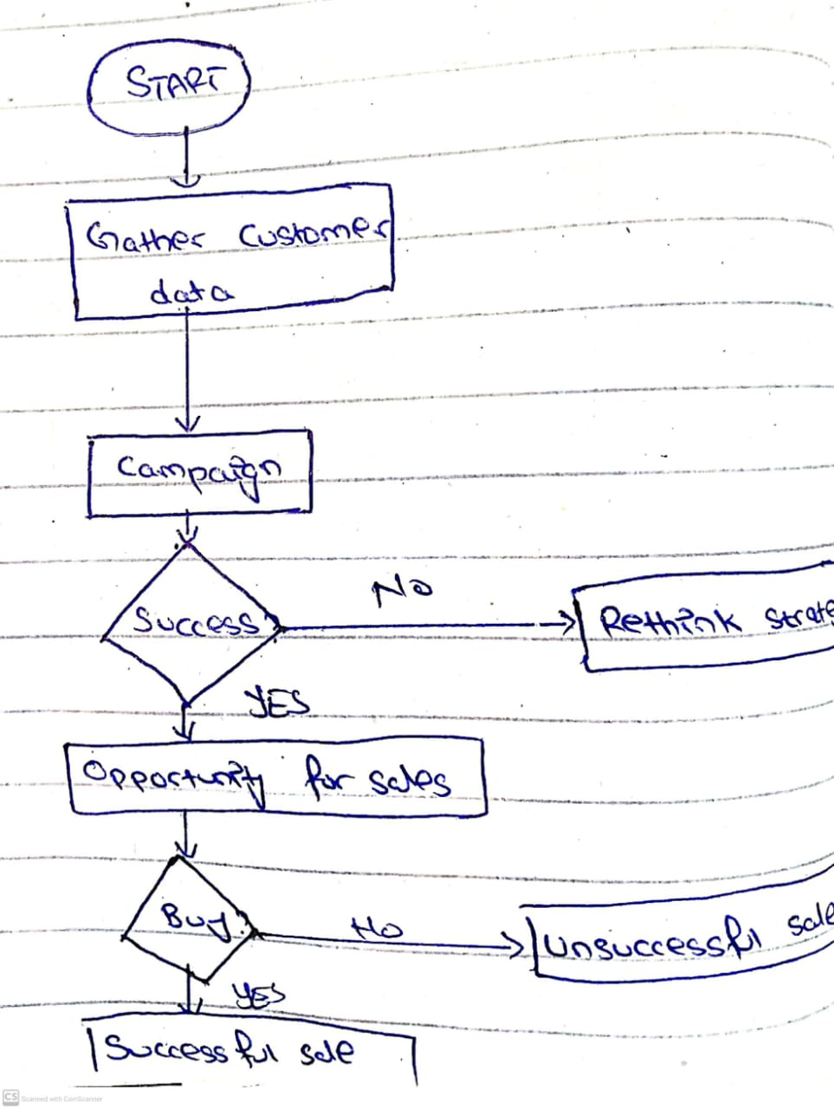

**AREA OF TRIANGLE**

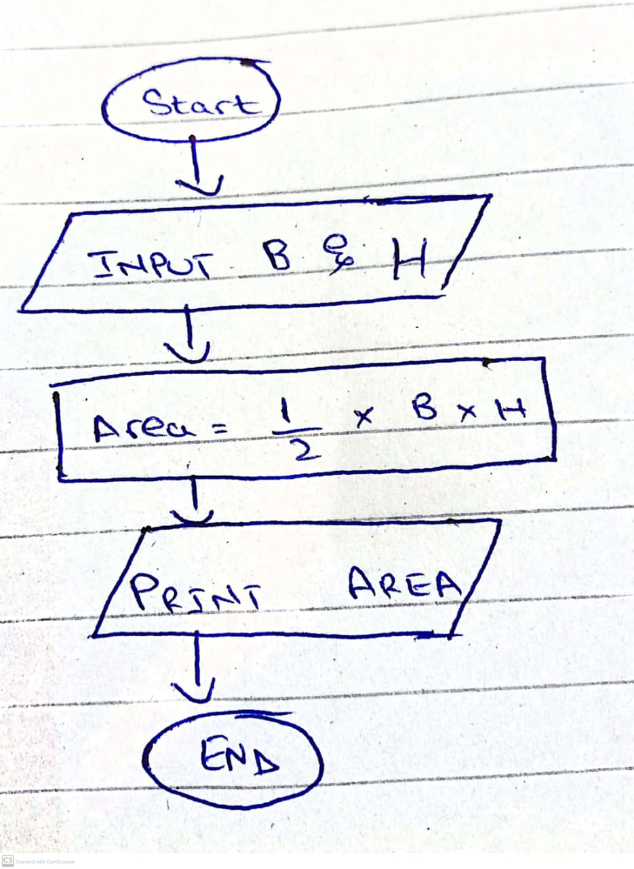

**IF TEMPERATURE IS BELOW 5 DEGREES A JACKET IS NEEDED.DRAW A FLOWCHART WHETHER A JACKET IS REQUIRED OR NOT**

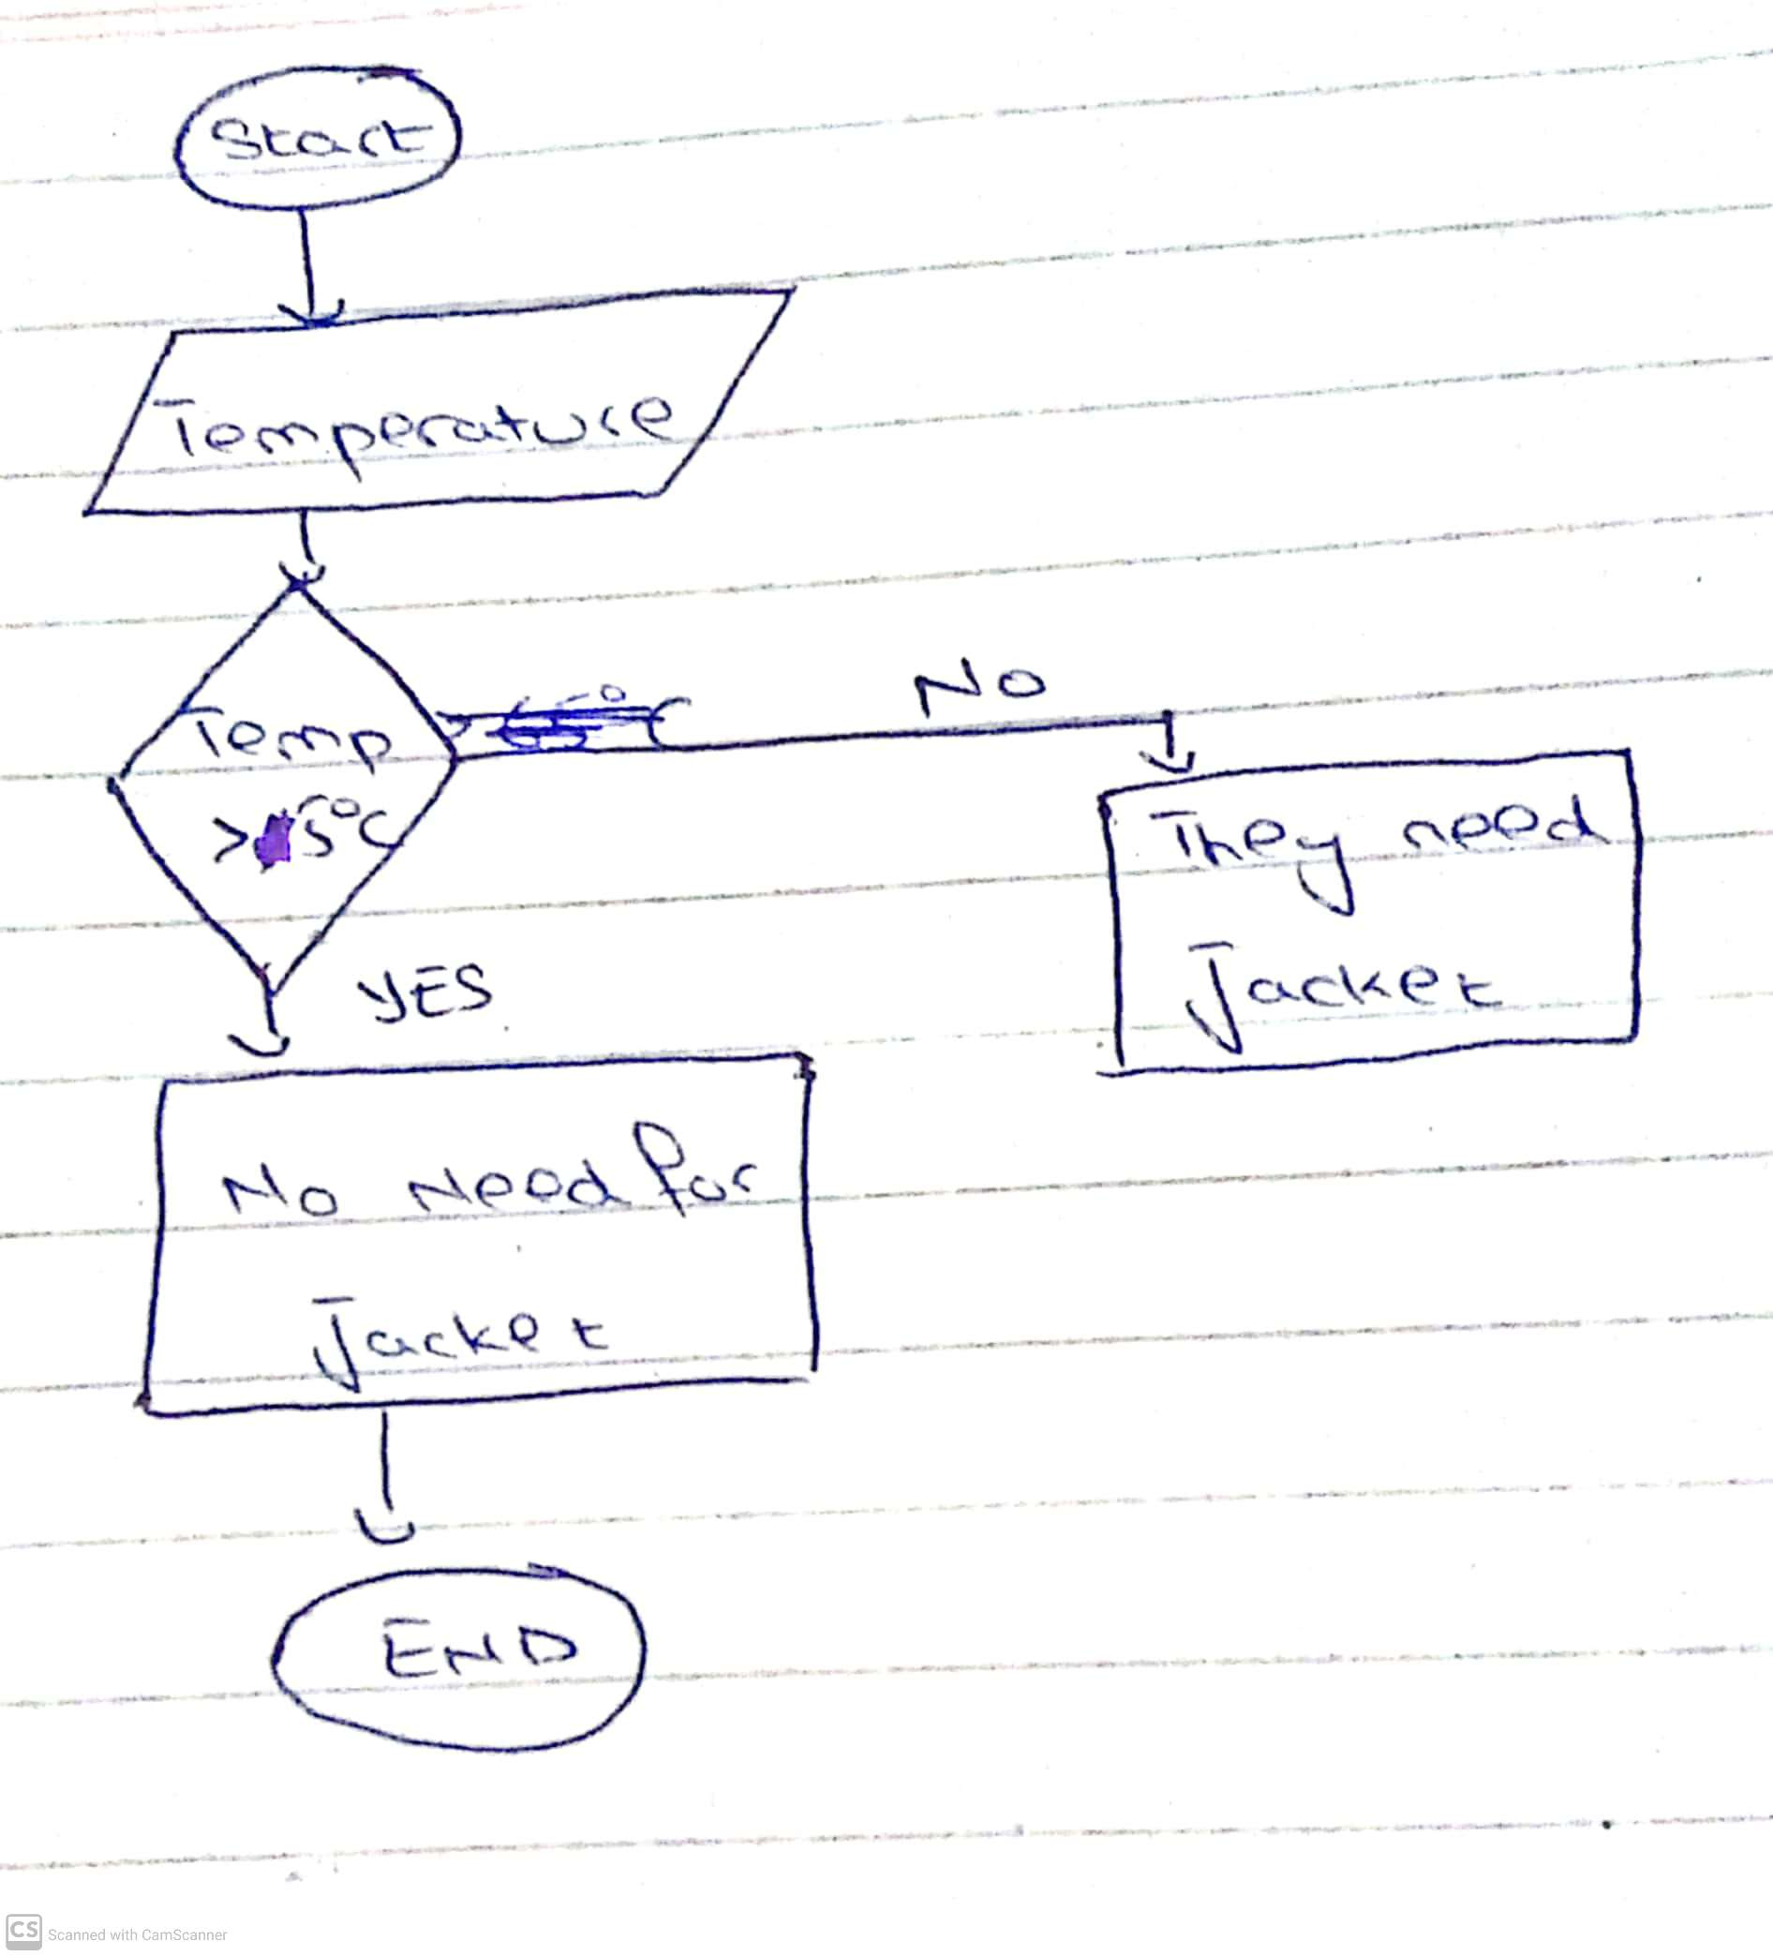

**LOG INTO THE EMAIL**

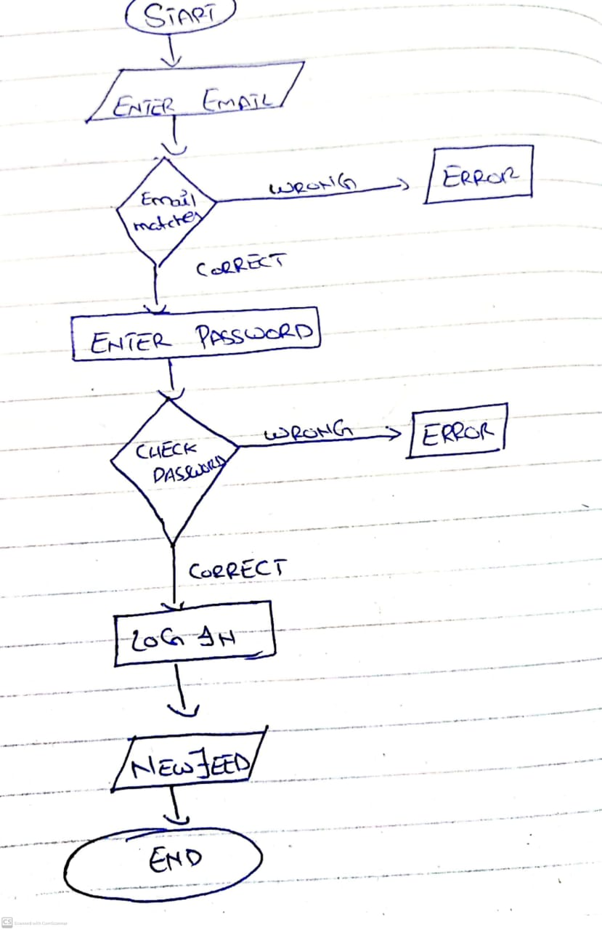

**ENTER PIN INTO THE ATM**

